1. login into portal.azure.com
NOTE：You must use Google Chrome browser， According to my test，Use QQ Browser or 360 Browser may give error， It is better to set use English Language.
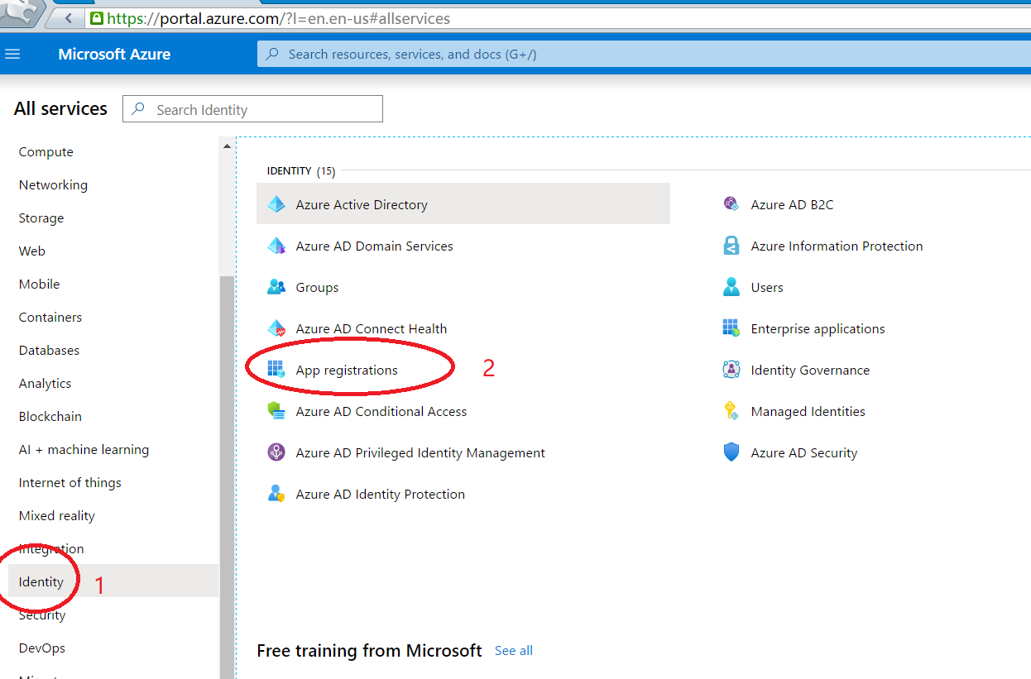

2.click New registration.

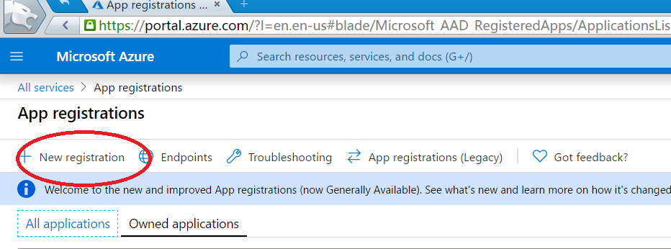

3. Fill the form
Step2 and Step3 choise others also OK
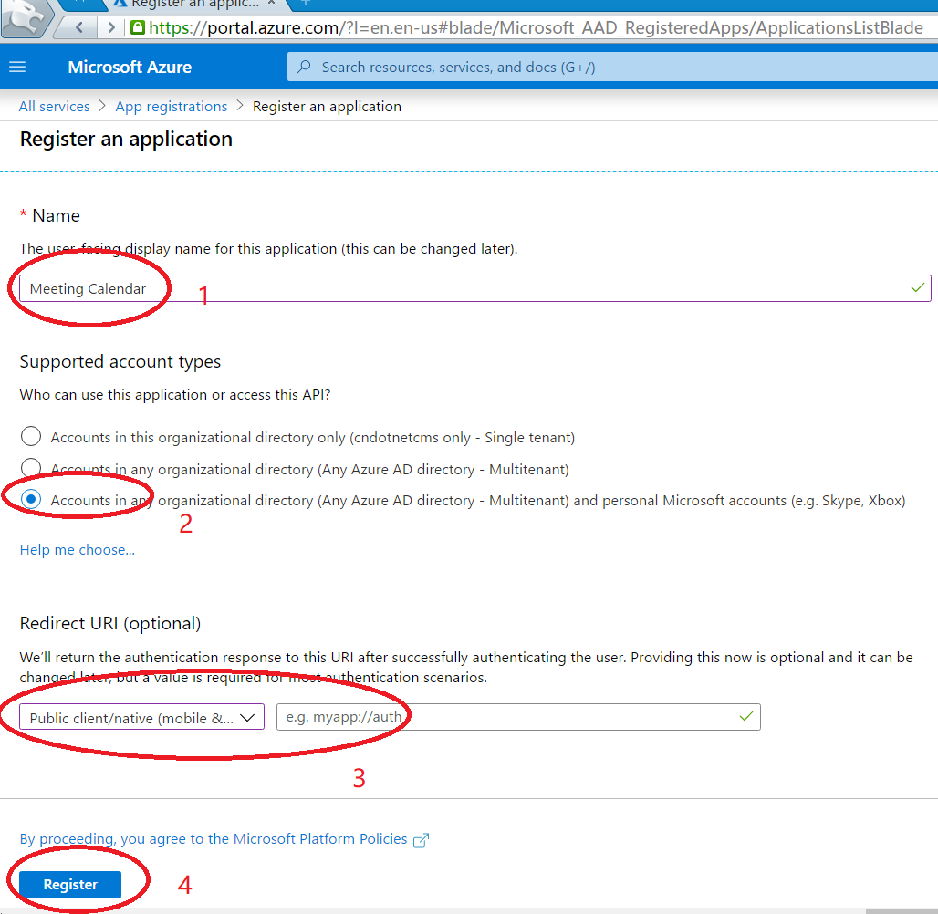

4. Get AppID and Tenant， we will use it later
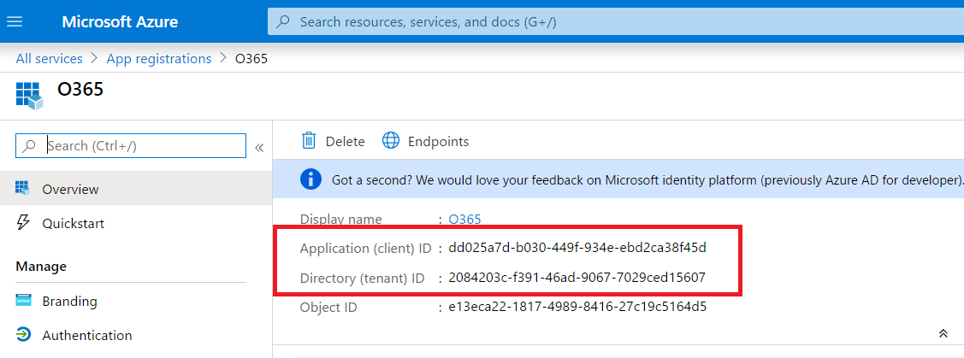

5.Create Secrets。we will use it later
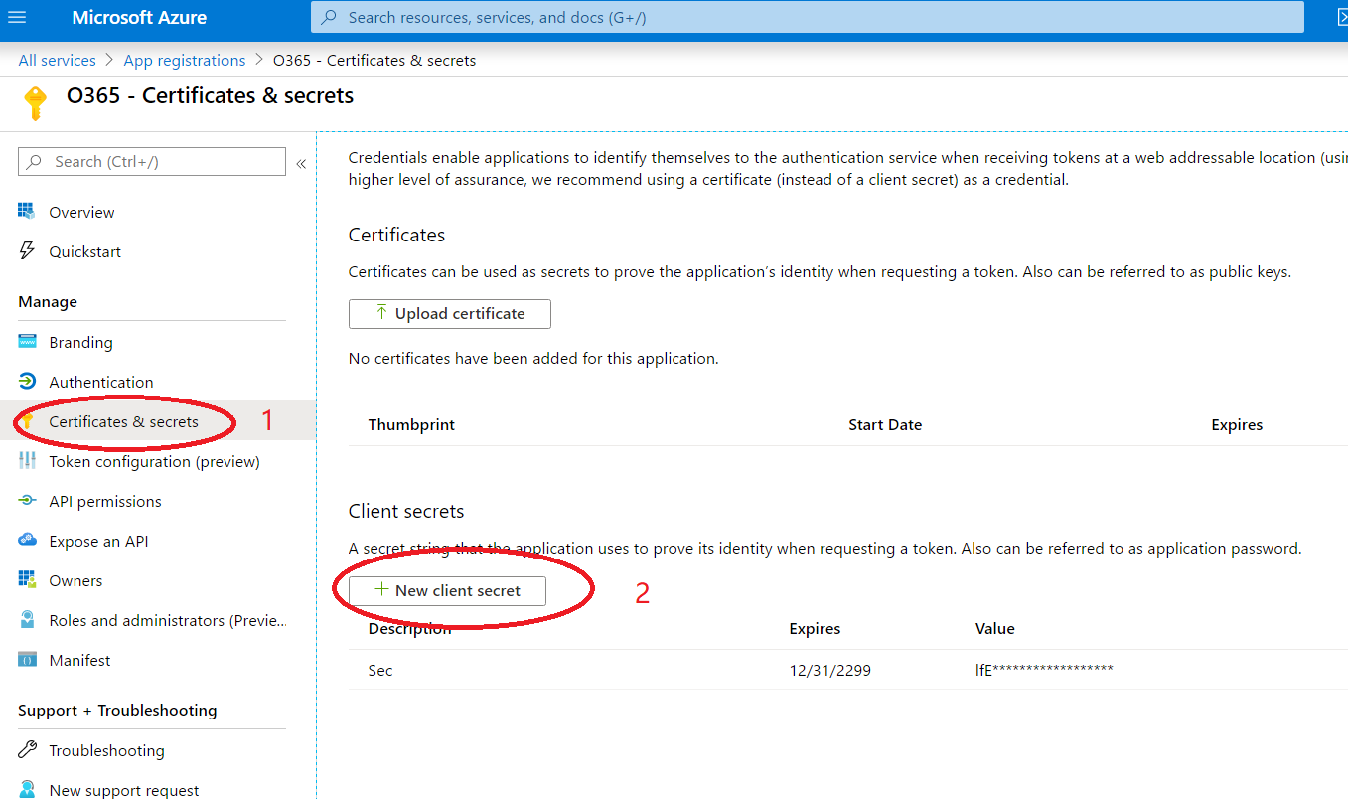

6. Click API permissions
add a permission, and then click “Microsoft Graph”
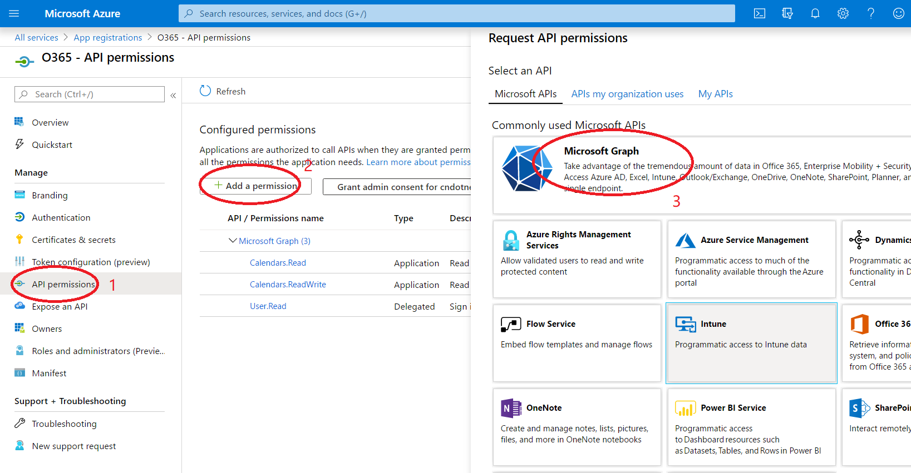

Click Application permissions, find Calendar API， Check Calendars Read.

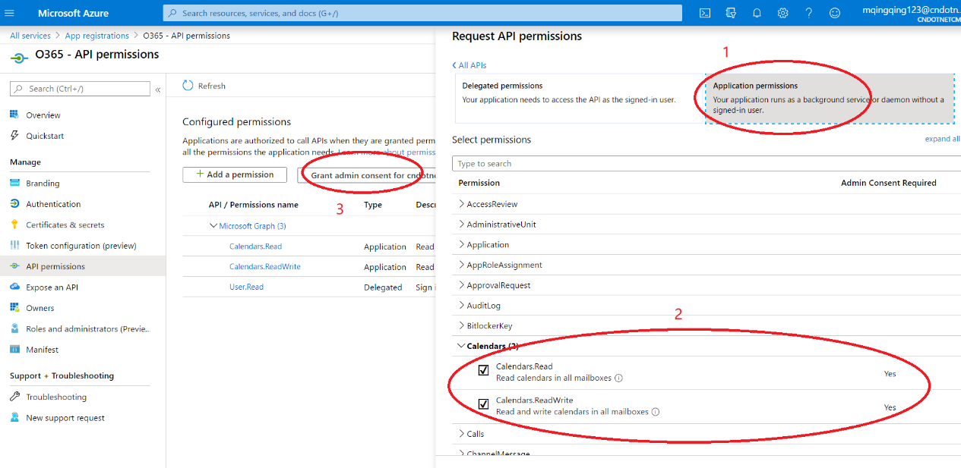

Grant use right。
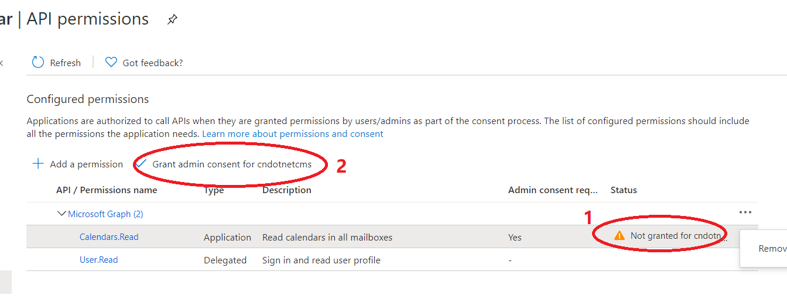

After that，you can see it like this。
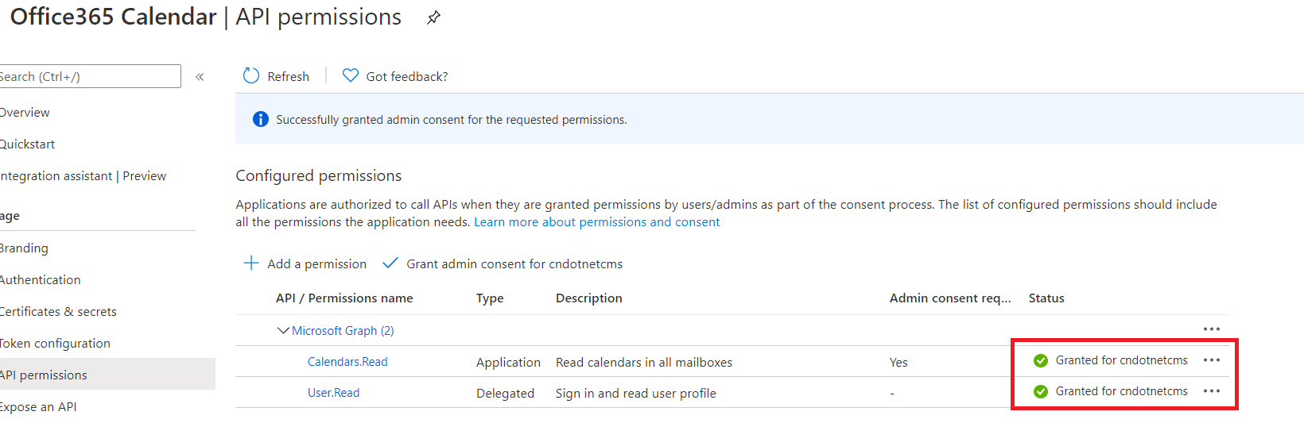

7.After finished configuration, send us appid, tenantid, secret.

if you have question send email 983506039@qq.com or view www.dotnetcms.org

